t
Skip to main conten

s
Career
e
Tweep Lif
y
Diversit
r
Early Caree
s
Location
s
Search role
Senior Software Engineer , FullStack - Global Participation
The Position
Who We Are:
The Global Participation engineering team is focused on Twitter’s topmost priority of growing active users globally; especially in
emerging/developing economies such as India and Africa. Our goal is to find new users as well as make existing users engage more
actively on a daily basis in these regions. We are building a foundational team in Bangalore where we expect to have a cross-functional
group of product managers, engineers, researchers, designers, operations, and data scientists, work as a single unit, obsessing about
user needs in these regions. We are looking to experiment heavily and iterate fast - if you like making an impact on a product that is used
by hundreds of millions of users, with full ownership, this is the team for you!
What You'll Do:
As a Senior web engineer on the global participation team, you will:
Work cross-functionally with committed teammates to build features on

twitter.co
m
.
Use your in-depth knowledge of modern web APIs and frameworks, such as React, Redux, React Router, GraphQL, webpack, to
develop solutions for conversational mechanics and media playback across devices and platforms — a unique challenge in web
development.
Develop strong skills and best practices internal and external to the team through participation in design and code reviews.
Take an active role in team processes, and product decisions. From using data and user feedback to help prioritize, to owning a
feature end-to-end, you’ll be engaged to do more than just writing code.
Participate in our educational culture, embracing opportunities to learn from Twitter’s community of web engineers, designers, and
product managers, as well as teaching us your strengths.
Be the recruiting champion and exemplary site citizen for Twitter globally as well as lead the upcoming growth of Twitter’s Bangalore
site.
The work you drive will play a key role in Twitter user satisfaction and growth. Existing customers will immediately benefit from this work,
and many more new customers worldwide will follow. You will empower people across the globe to connect and communicate.
Who You Are:
You have experience in a tech lead/architect capacity including setting technical direction for the team.
You have experience working closely with a variety of teams including product management, design, and infrastructure.
You want to apply your knowledge of web technologies to work on a product
You have a track record of designing and delivering reliable, efficient software and systems.
You are passionate about teaching: We put a high value on learning from each other. You should be skilled at pairing, teaching and
sharing things that you've learned.
You work as part of a team, including engineers in remote offices.
Bonus points: You also have experience with media on web, including audio and video playback
Qualifications
B.S. or higher in Computer Science, or 4+ years of relevant work experience
You are passionate about web development and have in-depth knowledge of modern web APIs and frameworks, such as React,
Redux,..
You have experience designing and building customer facing Progressive Web App(s)
Company Description
Twitter serves the public conversation because conversation is a force for good in the world. The opportunity to help the world connect,
debate, learn, and solve problems is what draws us to careers at Twitter, and it’s what keeps us here.
Additional Information
We are committed to an inclusive and diverse Twitter. Twitter is an equal opportunity employer. We do not discriminate based on race,
ethnicity, color, ancestry, national origin, religion, sex, sexual orientation, gender identity, age, disability, veteran, genetic information,
marital status or any other legally protected status.

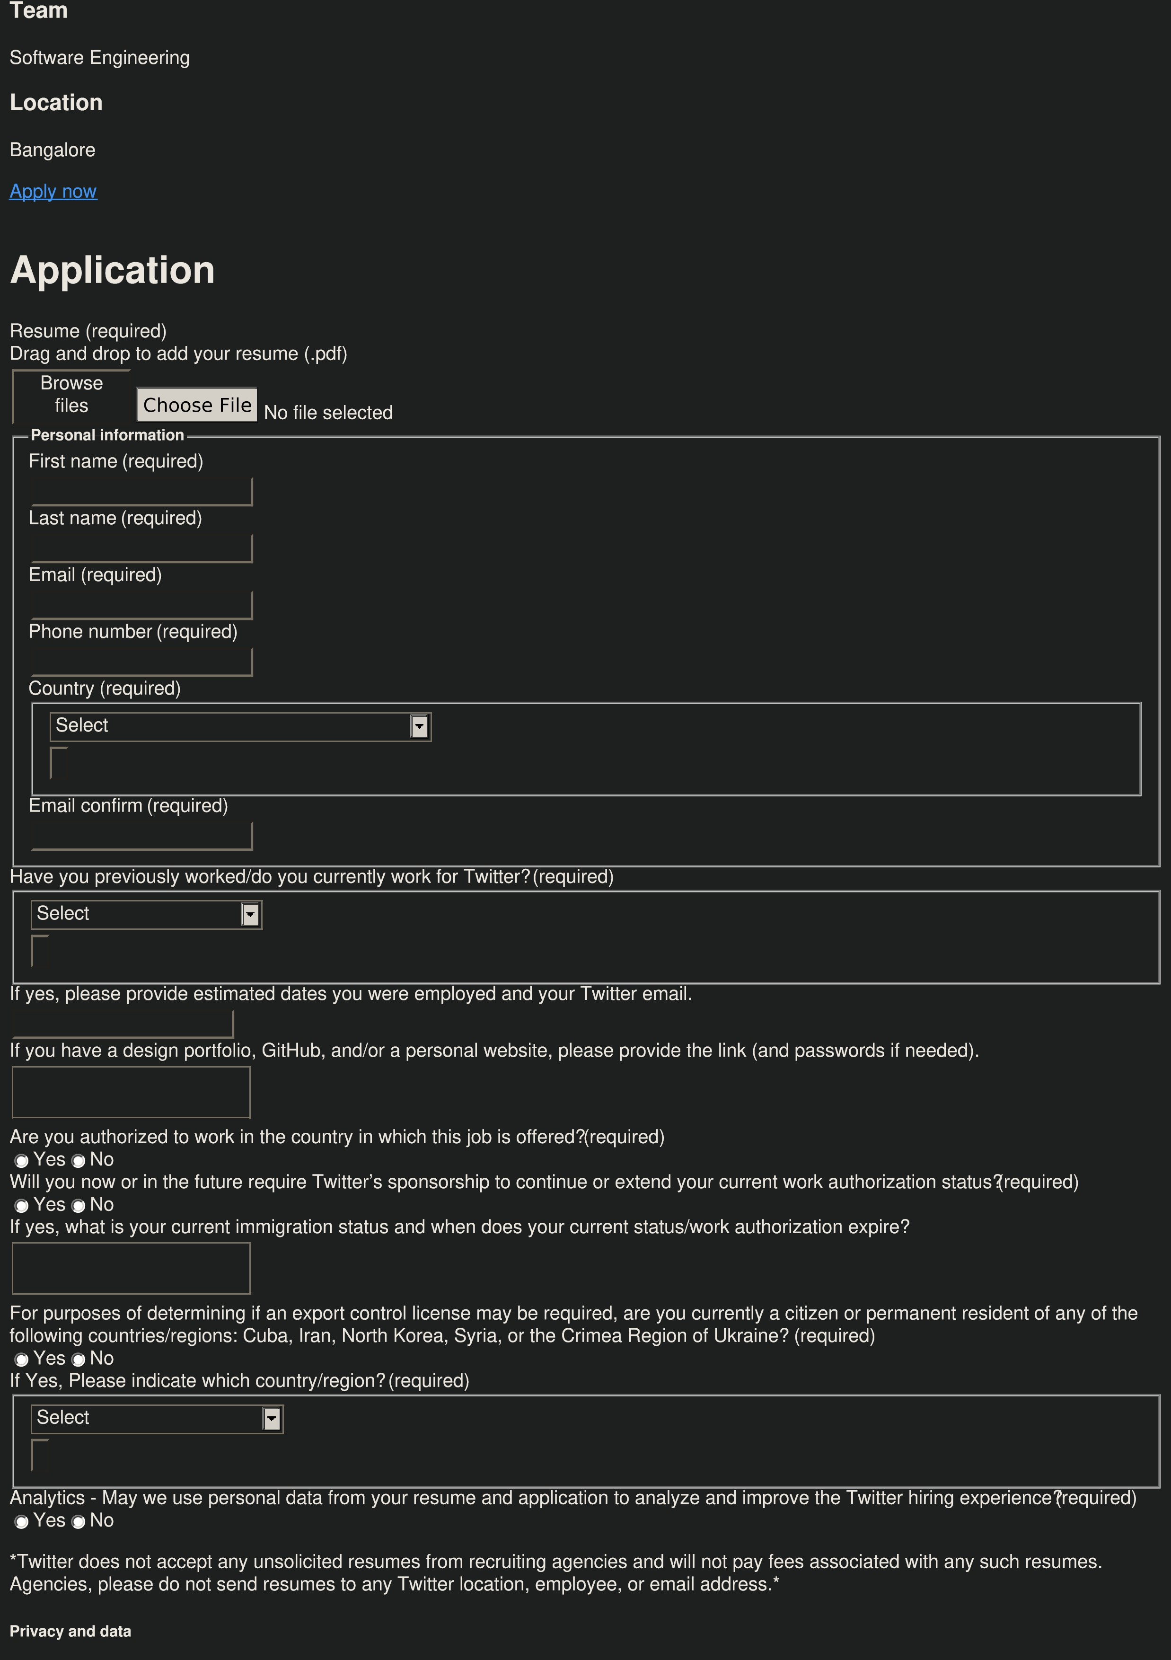

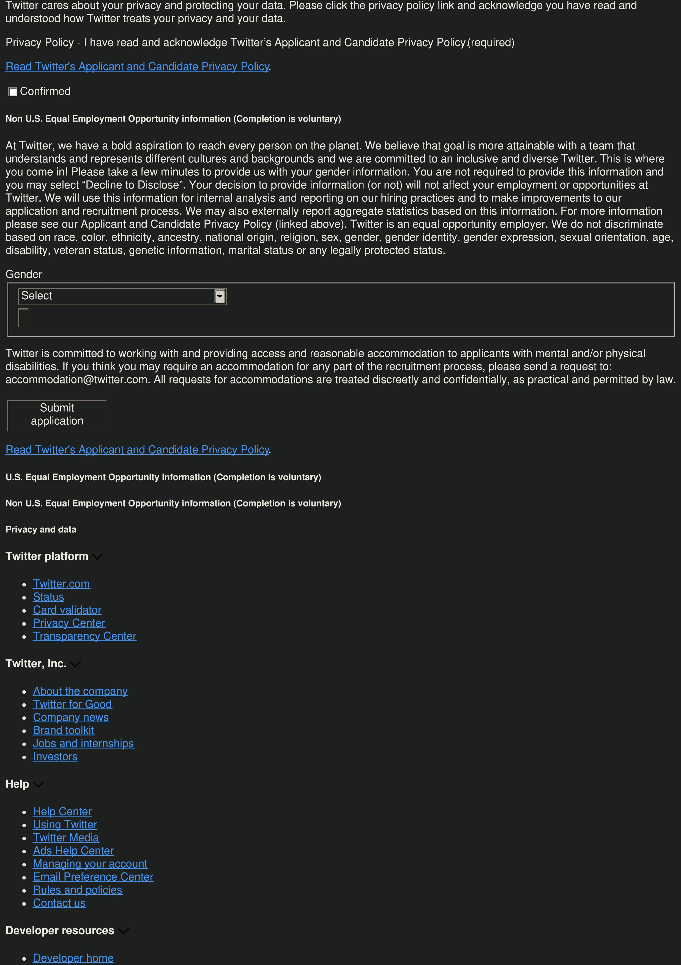

Documentatio
n
s
Forum
s
Communitie
g
Developer blo
Engineering blo
g
Developer term
s
Business resources
e
Advertis
Twitter for busines
s
Resources and guide
s
s
Twitter for marketer
s
Marketing insight
n
Brand inspiratio
l
Twitter Flight Schoo
© 2021 Twitter, Inc.
s
Cookie
Privac
y
Terms and condition
s
By using Twitter’s services you agree to our
e
Cookies Us
. We use cookies for purposes including analytics, personalisation, and ads.
OK
This page and certain other Twitter sites place and read third party cookies on your browser that are used for non-essential purposes
including targeting of ads. Through these cookies,
Googl
e
,
LinkedI
n
,
Glassdoo
r
and
Indee
d
collect personal data about you for their own
purposes.
Learn mor
e
.
Accept
Decline

